Assignment8

- In the March 16,1998, issue of Fortune magazine, the results of a survey of 2,221 MBA students from across the United States conducted by the Stockholm-based academic consulting firm Universum showed that only 20 percent of MBA students expect to stay at their first job five years or more. Assuming that a random sample was employed, find a 95 percent confidence interval for the proportion of all U.S.MBA students who expect to stay at their first job five years or more. Based on this interval, is there strong evidence that fewer than one-fourth of all U.S.MBA students expect to stay?
Solution:
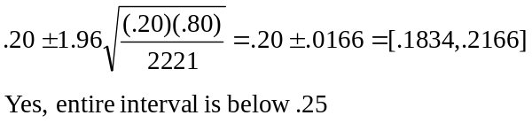

- Consolidated Power, a large electric power utility, has just built a modern nuclear power plant. This plant discharges waste that is allowed to flow into the Atlantic Ocean. The Environmental Protection Agency (EPA) has ordered that the waste water may not be excessively warm so that thermal pollution of the marine environment near the plant can be avoided. Because of this order, the waste water is allowed to cool in specially constructed ponds and is then released into the ocean. This cooling system works properly if the mean temperature of the waste water. A 60°F or cooler. Consolidated Power is required to monitor the temperature of the waste water. A sample of 100 temperature readings will be obtained each day, and if the sample results cast a substantial amount of doubt on the hypothesis that the cooling system is working properly( the mean temperature of waste water discharged is 60°F or cooler ), then the plant must be shut down and appropriate actions must be taken to correct the problem.
a Consolidated Power wished to set up a hypothesis test so that the power plant will be shut down when the null hypothesis is rejected. Set up the null hypothesis H₀ and the alternative hypothesis H_{a} that should be used.

b Suppose that Consolidated Power decides to use a level of significance of 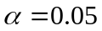, and suppose a random sample of 100 temperature readings is obtained. If the sample mean of the 100 temperature readings is 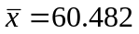, test H₀ versus H_{a} and determine whether the power plant should be shut down and the cooling system repaired. Perform the hypothesis test by using a critical value and a p-value. Assume 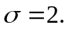
Solution:
a. : μ ≤ 60 versus : μ > 60.
b.
Since 2.41 > 1.645 we reject for α = 0.05. p-value = 1 – 0.9920 = 0.0080 and since 0.0080 < 0.05 we draw the same conclusion so the plant should be shut down and the cooling system repaired.

- In the book Business Research Methods, Donald R. Cooper and C. William Emory (1995) discuss using hypothesis testing to study receivables outstanding. To quote Cooper and Emory:
the controller of a large retail chain may be concerned about a possible slowdown in payments by the company’s customers. She measures the rate of payment is terms of the average number of days receivables outstanding. Generally, the company has maintained an average of 50 days with a standard deviation of 10 days. Since it would be too expensive to analyze all of a company’s receivables frequently, we normally resort to sampling.

a Set up the null and alternative hypotheses needed to attempt to show that there has been a slowdown in payments by the company’s customer (there has been a slowdown if the average days outstanding exceeds 50).

b Assume approximate normality and suppose that a random sample of 25 accounts gives an average days outstanding of 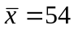 with a standard deviation of s=8. Use critical values to test the hypotheses you set up in part a at level of significance 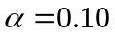,,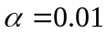, and 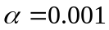. How much evidence is there of a slowdown in payments?

c Are you qualified to decide whether this result has practical importance? Who would be?
Solution:
a. : μ ≤ 50 versus : μ > 50
b.
24 degrees of freedom,
Since 2.492 < 2.5 < 3.467, reject at α = .10, .05, .01, but not at α = .001.
There is very strong evidence that is false.

